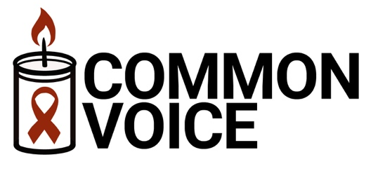
Interreligious Advocacy
and Action to End AIDS

Responsive Reading Video
Leader’s Guide

The Common Voice Responsive Reading Video is intended for use in worship services or other settings involving the religious response to the AIDS epidemic. The video is available online at https://vimeo.com/waragainstaids/commonvoicepledge
The video has three main parts:
- A short summary of the global response to HIV and AIDS (1 min)
- A responsive reading of selected portions of the Common Voice Pledge (4:15)
- One verse of “We’ll Walk Hand in Hand” (1 min)
You may feel free to use the parts separately if you wish.
The text of the Common Voice responsive reading is on the next page. You may feel free to print it for inclusion in your worship program if you wish. Participation by you and by members of your congregation is indicated by the labeling of the lines of the pledge.
- The first two lines are said by global religious leaders on the video
- Sections labeled “Leader” are said by religious leaders on the video. You may join them if you wish. The video shows the text in a small font at the bottom of the screen.
- Sections labeled “Response” are to be read by the members of your congregation. The video shows the text in a large font in the middle of the screen.
- Sections labeled “All” are to be read by you together with the members of your congregation. The video shows the text in a large font in the middle of the screen.
- The song “We’ll Walk Hand in Hand” is to be sung by you together with members of your congregation, holding hands if possible.
More information about the Common Voice initiative is available at www.CommonVoiceAIDS.org.

Common Voice Pledge
The AIDS epidemic is at a critical point. A remarkable, decades-long global effort has given us the capability to end AIDS as a public health threat. However, the global political will to end AIDS is weakening, raising the risk of a major resurgence of the epidemic in the 2020s. Strong advocacy by religious voices is vital to ensuring that the world perseveres and finally brings the AIDS epidemic to an end.
The Common Voice Pledge is an interreligious expression of advocacy and commitment to end AIDS. This responsive reading includes selected portions of the Common Voice Pledge. The full pledge may be found on the Common Voice website: www.CommonVoiceAIDS.org.

As leaders and followers of different religious traditions, we are speaking together with a common voice to urgently demand that the world re-commit to ending AIDS.
We are speaking with a common voice because our diverse religious traditions share many sacred values.
All: We share a conviction that all human beings must be treated with dignity and respect.
All: We share a responsibility to reach out to the marginalized and to protect the vulnerable.
Leader: Although HIV and AIDS affect different people, regions, and social groups differently, we know that the epidemic affects the entire human community.
Response: As members of the human community, we commit to playing our part in bringing the AIDS epidemic to an end.
Leader: We recognize that religious beliefs and practices have sometimes been used to justify judgmental attitudes and that the resulting stigma and discrimination have harmed people living with HIV and have weakened the global response to the AIDS epidemic.
Response: We reject these judgmental attitudes and we commit to fighting stigma and discrimination within our religious communities and within society at large.
Leader: We believe that all people should have access to HIV prevention and treatment services, including people who are marginalized by society.
Response: We strongly urge universal access to HIV services, provided with dignity and respect, and without stigma, discrimination, or fear of criminal prosecution.
Leader: We believe that our religious communities must be places of hope for people living with HIV.
Response: We commit to providing HIV services that address each unique individual’s physical, social, emotional, and spiritual needs.
Leader: We believe that followers of our religious traditions have a personal responsibility to know their HIV status and to refrain from behavior that risks transmission of HIV.
Response: We commit to equipping members of our communities with knowledge about all HIV prevention methods so that they can take responsibility for avoiding HIV transmission.
All: Compelled by our common values, and with prayers for perseverance, wisdom, and divine guidance, we commit to building bridges with other religious traditions and we invite followers of all traditions to join us as we work together to end AIDS.

